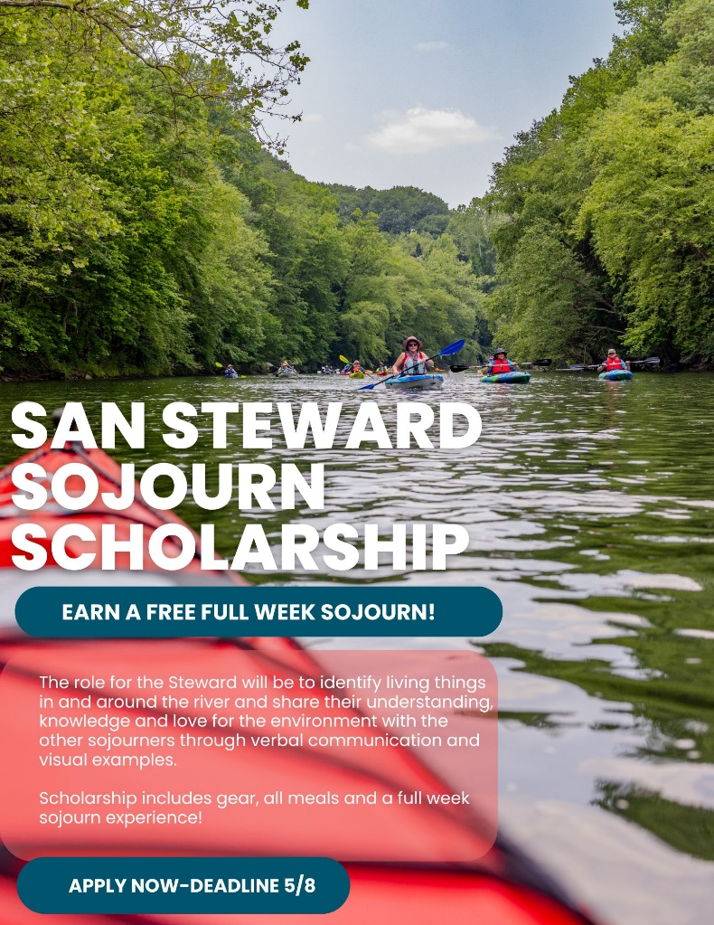
We’re searching for a nature enthusiast!
Are you passionate about environmental conservation? Do you possess a wealth of knowledge on local ecosystems, and do you love sharing what you know with others? And - do you LOVE to paddle? – Then YOU could be the next Sojourn Steward joinign an unforgettable journey down the Schuylkill, exploring nature along the way!
This year’s theme, “Our Living River,” includes programming that will focus on the flora and fauna, critters and creatures and all things living in and around the Schuylkill River. Topics include eels, crayfish, butterflies, invasive plants, raptors, water quality and much much more.
We are seeking a Steward to join the week-long Schuylkill Sojourn, traversing the Schuylkill River and engaging fellow paddlers in nature-based learning along the way. This year’s Steward should have a strong passion for environmental conservation, an understanding of local biology, ecology, flora and fauna, and excellent communication skills to engage and educate diverse audiences. Strong knowledge of native and invasive plant species, aquatic organisms, and wildlife commonly found in the Schuylkill River watershed would be useful for this role.
The role for the Steward will be to identify living things in and around the river and share their understanding, knowledge and love for the environment with the other sojourners through verbal communication and visual examples.
Additional tasks for the 2024 Steward include:
- Takeover the Schuylkill Action Network (SAN) Instagram for the week to highlight the daily discoveries.
- Photograph and identify the biodiversity that exists along the river.
- Share a 20 - 30 minute presentation providing an update on the week so far and discuss what has been found along the way.
- Optionally, use iNaturalist to record each day’s findings and engage and educate other sojourners on the iNaturalist program.

Additional details:
The 2024 Schuylkill River Sojourn is June 15 - June 21 and the Steward must be available for the entire trip.
The SAN Steward will paddle all seven days of the Sojourn and be a full trip participant along with hundreds of other paddlers. Please know that the sojourn is physically arduous and the Steward must be able to paddle approximately 15 miles a day along with the other physical tasks required to get down the river. This includes navigating portages around dams and carrying kayaks at put-ins and take-outs, as well as setting up a tent each night.
The Steward is welcome to bring their own kayak, paddle and PFD if they own one. However, Schuylkill River Greenways (SRG) and their outfitter would be happy to set you up with all of the paddling gear you will need for the week free of charge.
Additionally – the Steward will need all camping gear for a full week including a tent, rainfly, tarp, sleeping pad, sleeping bag, dry bag, etc. If the Steward can not supply those items, they will be provided through the Sojourn outfitter free of charge.
3 meals are provided each day. The Sojourn host communities work very hard to ensure many options at each meal. Vegetarian options will be available at all meals. If you have additional dietary requirements beyond a vegetarian option, you will need to provide those items for yourself for the week. SRG would be happy to discuss transport of items that do not need to be refrigerated.

Click here to apply: Schuylkill River Sojourn Steward Application (jotform.com)

