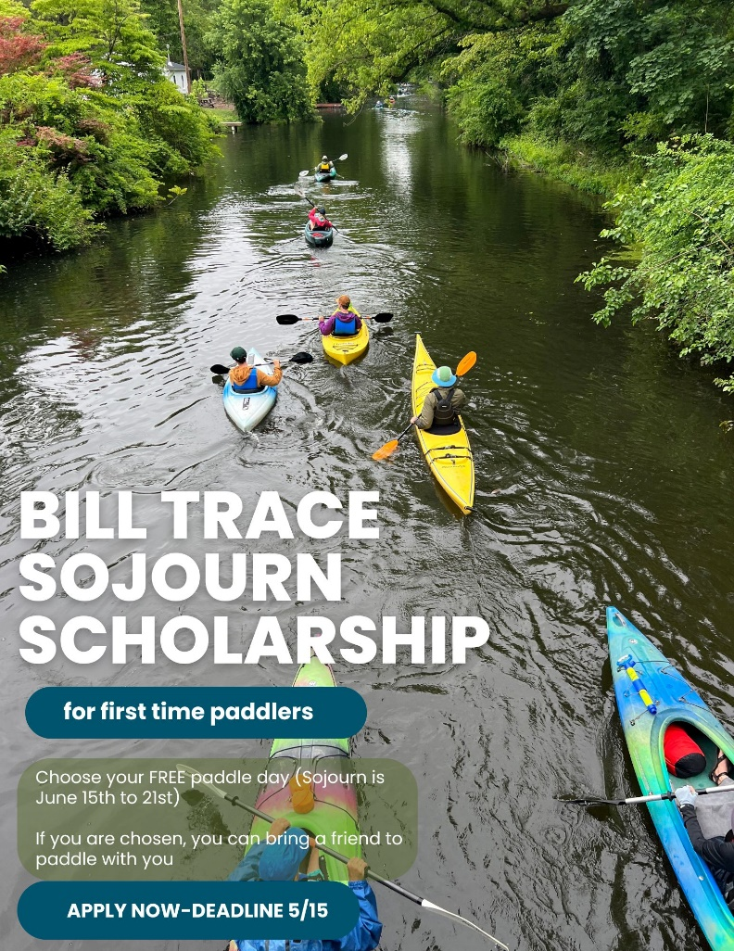

In memory of Bill Trace, a longtime sojourner and devoted member of Schuylkill River Greenways, a fund has been established through the generosity of his friends and family. The Bill Trace Scholarship includes a free one day paddle on the sojourn for the recipient and a guest who have never been on the Sojourn before.

You must be 18 or over to apply and fill out the application form here:

Bill Trace Sojourn Scholarship (office.com)

